Experiment-28
In a class, an English teacher was teaching the vowels and consonants to the students. She says “Vowel sounds allow the air to flow freely, causing the chin to drop noticeably, whilst consonant sounds are produced by restricting the air flow”. As a class activity the students are asked to identify the vowels and consonants in the given word/sentence and count the number of elements in each. Write an algorithm to help the student to count the number of vowels and consonants in the given sentence.
Code:
%{
#include <stdio.h>
int vowels=0, consonants=0;
%}
%%
[AEIOUaeiou] { vowels++; } [a-zA-Z] { consonants++; }
.|\n ;
%%
int main(){ yylex(); printf("Vowels: %d\nConsonants: %d\n", vowels, consonants); return 0; } int yywrap(){ return 1; }
Output:
Hello World Vowels: 3
Consonants: 7
Output Screenshot:
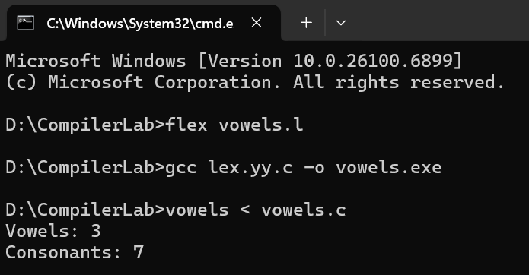

Experiment-29
Keywords are predefined, reserved words used in programming that have special meanings to the compiler. Keywords are part of the syntax and they cannot be used as an identifier. In general there are 32 keywords. The prime function of Lexical Analyser is token
Generation. Among the 6 types of tokens, differentiating Keyword and Identifier is a challenging issue. Thus write a LEX program to separate keywords and identifiers.
Code:
%{
#include <stdio.h>
%} KEYWORD
(int|float|char|double|void|return|if|else|for|while|break|continue|switch|case|printf|scanf|main) ID [a-zA-Z_][a-zA-Z0-9_]*
%%
{KEYWORD} { printf("Keyword: %s\n", yytext); }
{ID} { printf("Identifier: %s\n", yytext); } [ \t\n;,\(\)\{\}] ;
. ;
%%
int main(){ yylex(); return 0; } int yywrap(){ return 1; } Output:
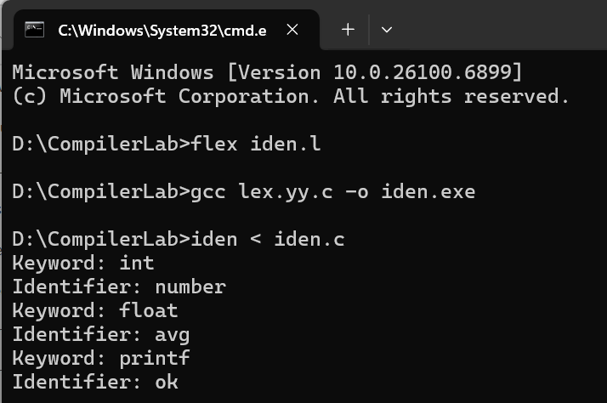
Experiment-30
Write a LEX program to recognise numbers and words in a statement. Pooja is a small girl of age 3 always fond of games. Due to the pandemic, she was not allowed to play outside. So her mother designs a gaming event by showing a flash card. Pooja has to separate the numbers in one list and words in another list shown in the flash card.
Code:
%{
#include <stdio.h>
%}
%%
[0-9]+ { printf("Number: %s\n", yytext); }
[a-zA-Z]+ { printf("Word: %s\n", yytext); }
.|\n ;
%%
int main(){ yylex(); return 0; } int yywrap(){ return 1; } Output:
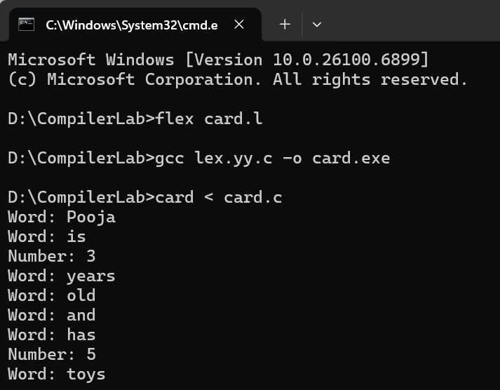

Experiment-31
Write a LEX program to identify and count positive and negative numbers. Code:
%{
#include <stdio.h> int pos=0, neg=0;
%}
%%
-[0-9]+ { neg++; printf("Negative: %s\n", yytext); } [0-9]+ { pos++; printf("Positive: %s\n", yytext); }
.|\n ;
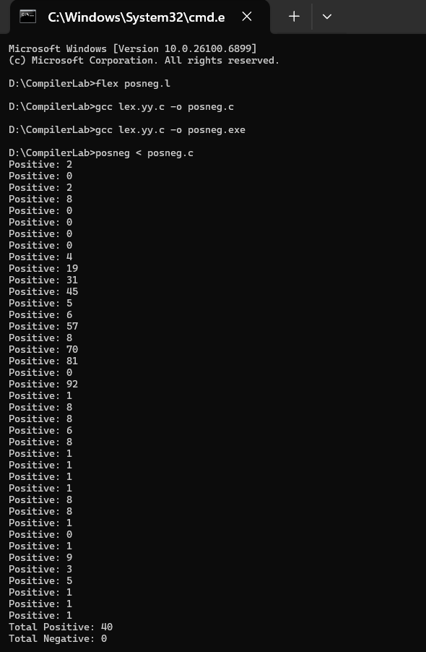
Output

Experiment-32
A networking company wants to validate the URL for their clients. Write a LEX program to implement the same.
Code:
%{
#include <stdio.h>
%}
%%
(https?://)?(www\.)?[a-zA-Z0-9.-]+\.[a-zA-Z]{2,}(/[a-zA-Z0-9._-]*)* { printf("Valid URL:
%s\n", yytext); }
[^\n]+ { printf("Invalid URL: %s\n", yytext); }
\n ;
%%
int main(){ yylex(); return 0; } int yywrap(){ return 1; } Output:
